**Post-Development Testing**

I am now able to test the final game myself using the black box test plan I made back in the design stage. A reminder of this test plan can be found as part of my Appendixes.  
Appendix D shows the test plan completed while the following pages shows the detail of me carrying out the tests.

**Menu:**

Test 1) Click on Help Button (These follow the Help Button Testing Section):

**Help Button:**

Test 1a) Click the help button:

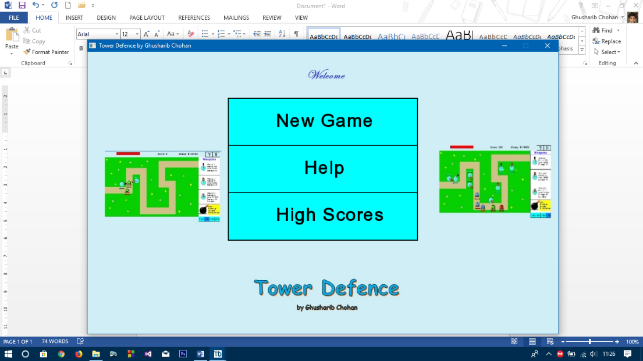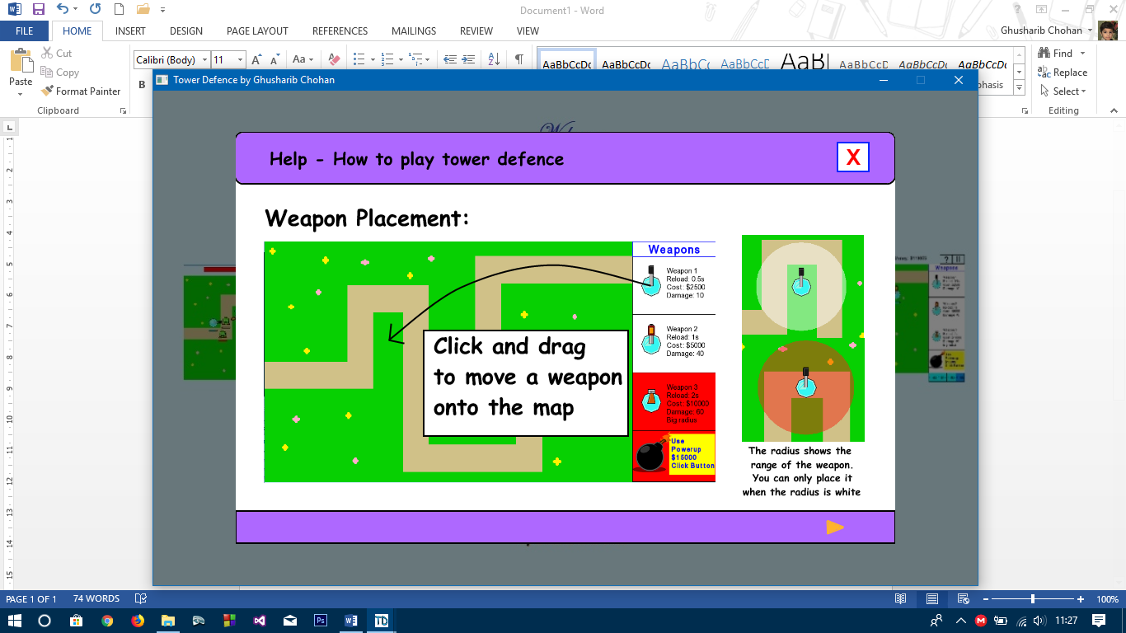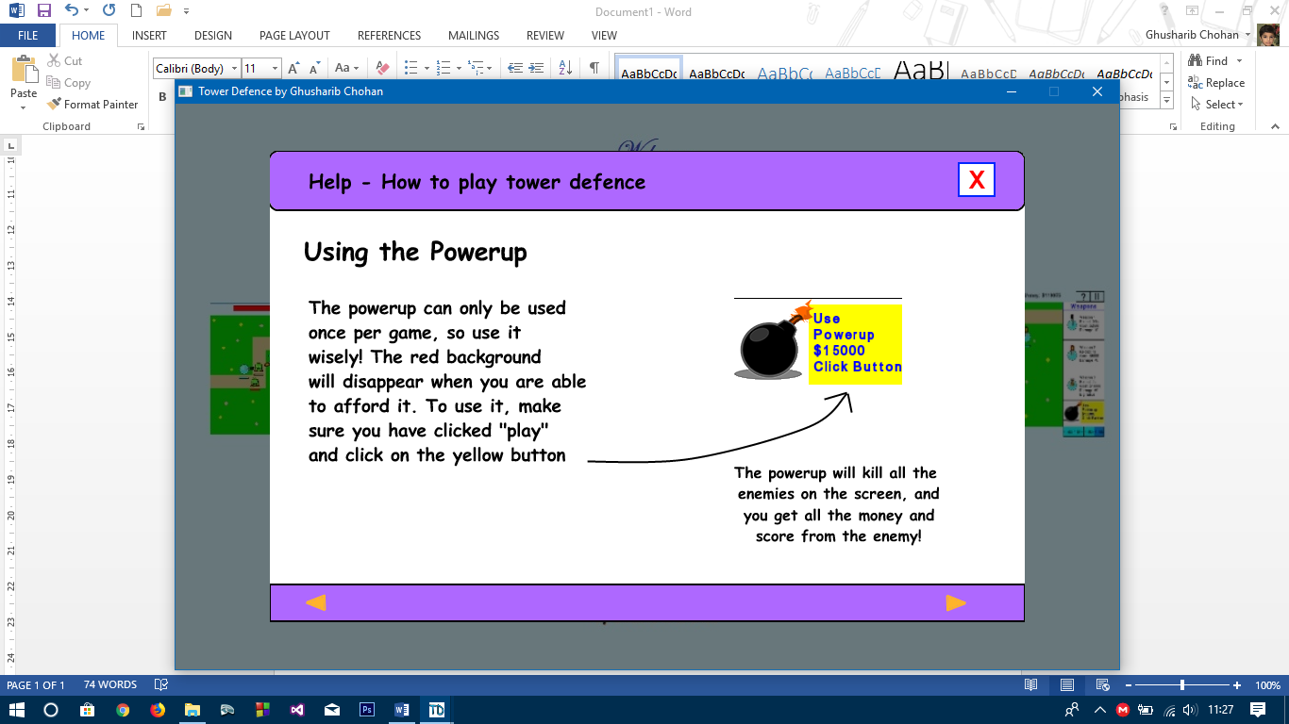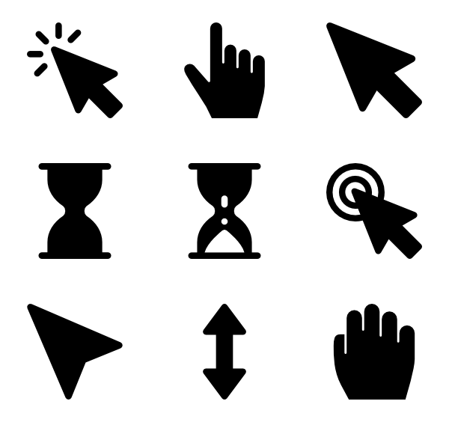

I click on the “Help” button from the main menu

The help screen loads and I press on the “Next” Button

The help screen displays and pressing on the next button takes me to the next help screen and so on **[TEST PASSED]**

Test 1b) Click on close button on the help screen

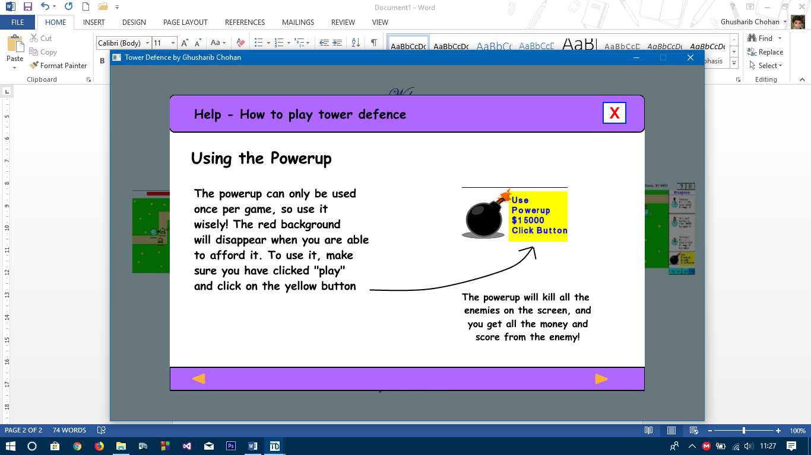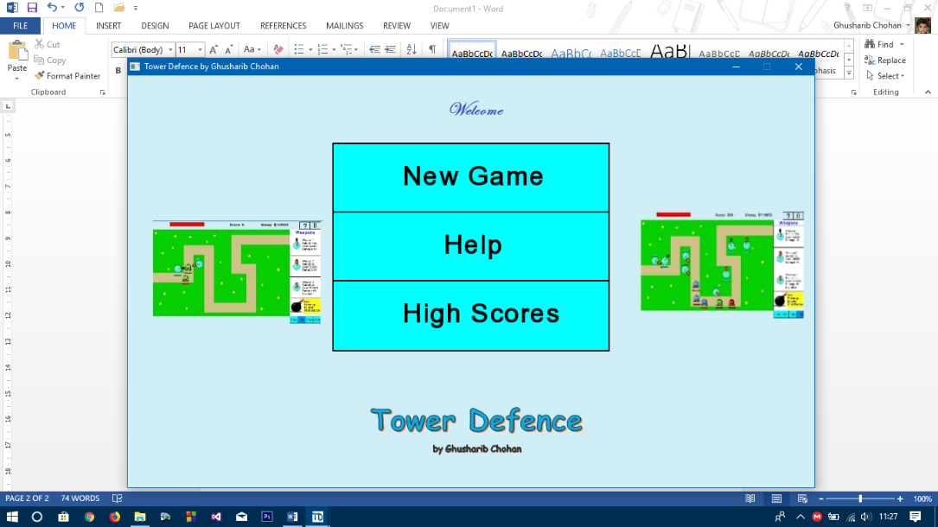

I click on the “Close” Button on the Help Screen.

Help screen closes and returns to the previous screen **[TEST PASSED]**

**Continue Menu:**

Test 2) Click on High Scores Button:

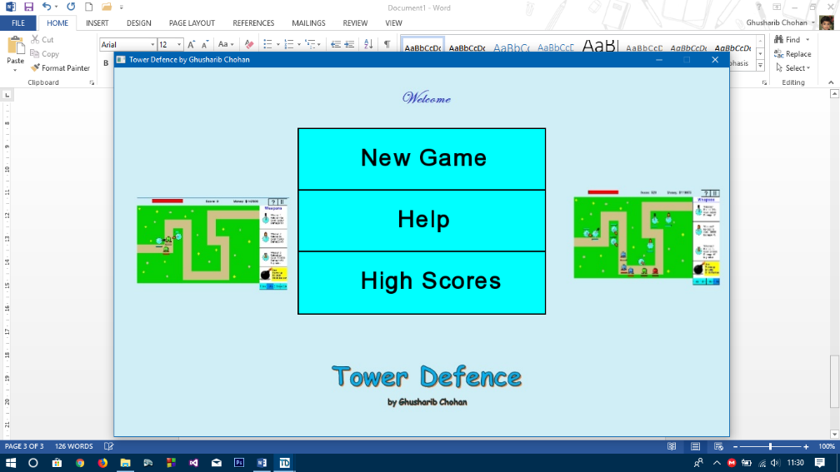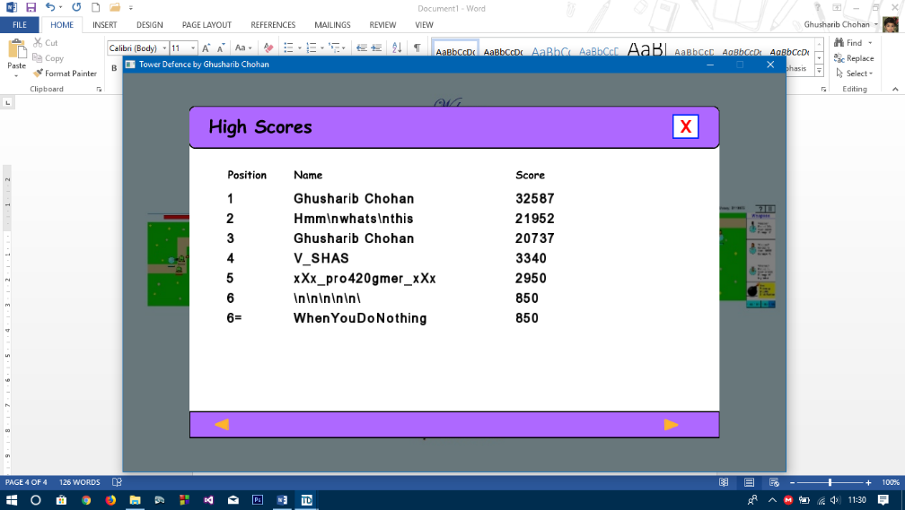

High Scores are displayed and appear in the correct order (with descending scores)

**[TEST PASSED]**

Test 3) Click on New Game

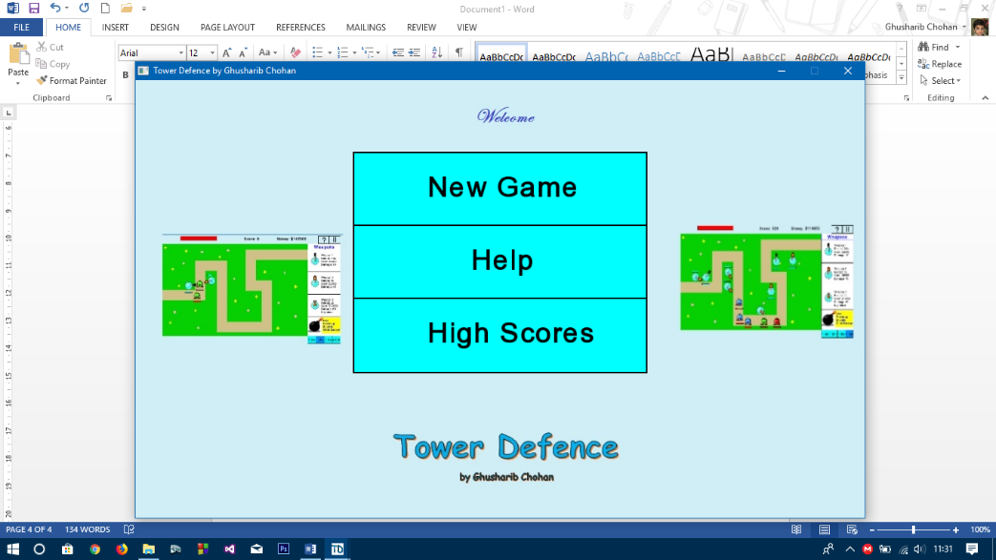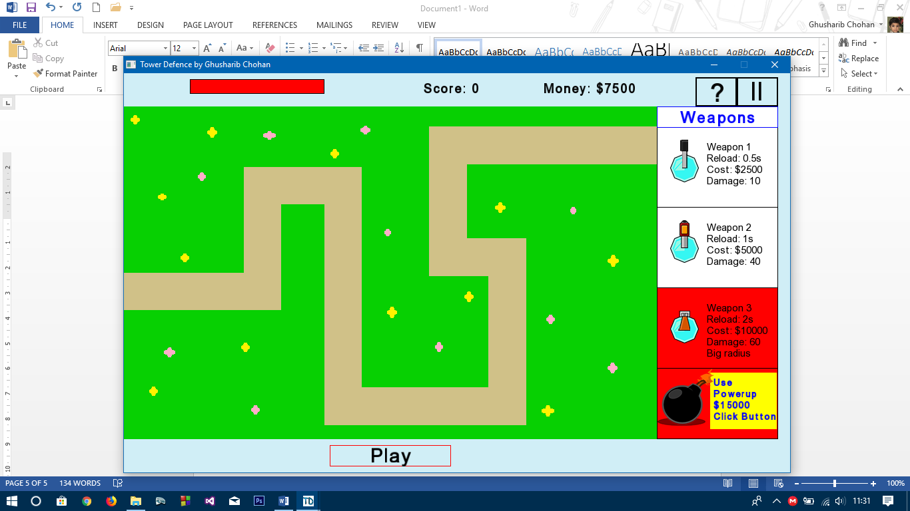

I click on the “New Game” button from the Main Menu

New Game starts with 0 Score and $7500 in money (to allow them to buy weapons) with a blank map.

**[TEST PASSED]**

**Click and Drag Feature**

Test 1) Add Weapon with enough money and to a valid place

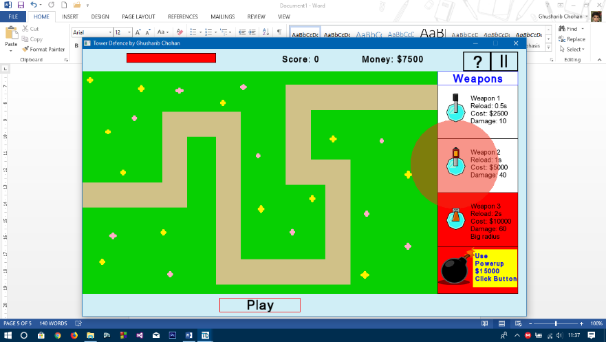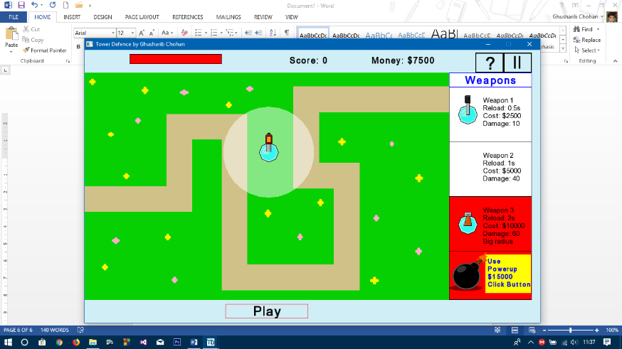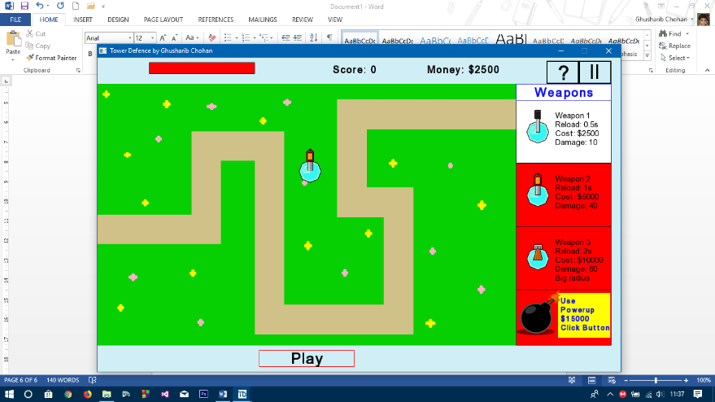

The Weapon has been added to the part of the screen it was dragged to and the money has decreased **[TEST PASSED]**

Test 2) Click on weapon and attempt to drag to a valid part of screen without enough money

Test 3) Click on weapon and attempt to drag to an invalid part of screen without enough money (These are combined as they can be checked together

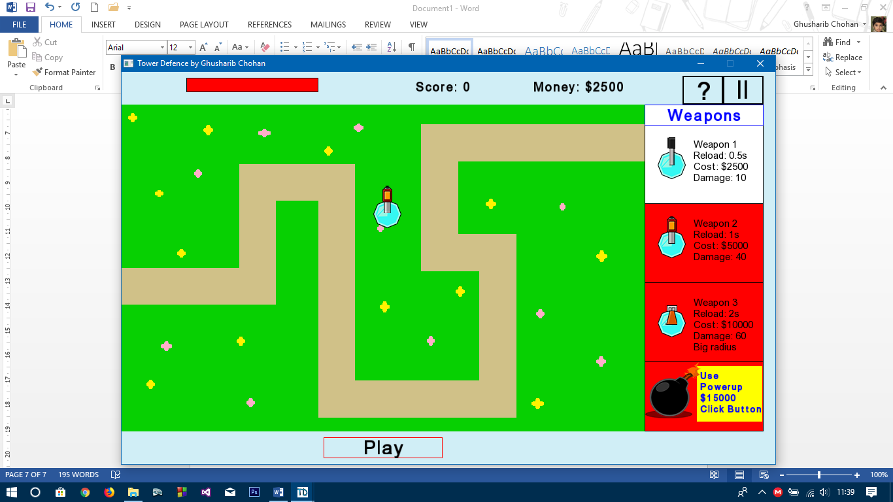

As can be seen in the screen above, the Weapon 2 has a red fill to it. This is the feedback given to the user showing they cannot buy that weapon (as a replacement to adding unecessary text messages). In addition, you are not able to drag the weapon anywhere so the weapon cannot be dragged to an invalid part of the screen.

**[TEST PASSED]**

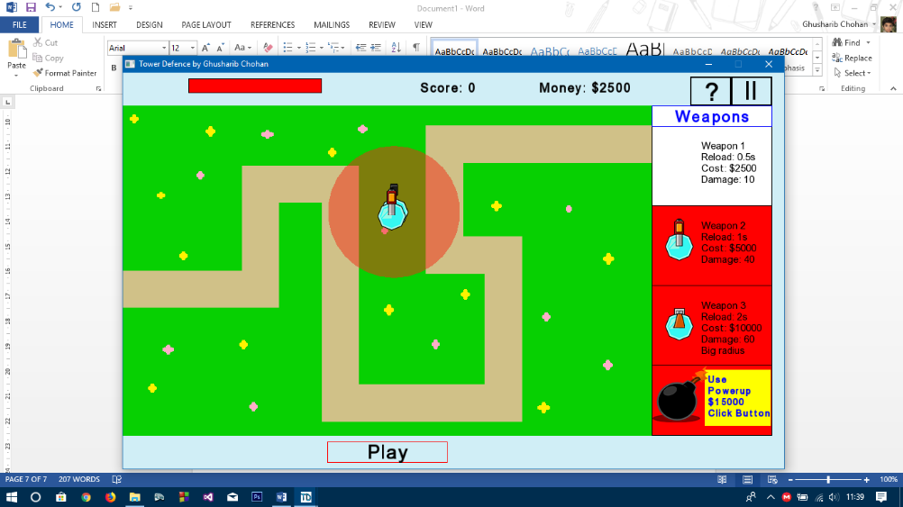Test 4) Click on weapon and drag on top of another weapon

The red radius shows that this weapon cannot be added to this position, giving the user feedback without a message but instead in the form of visual feedback. This means that weapons cannot be placed on top of each other.

As can be seen in these two screenshots, the weapon can not be placed on top of another until it’s base is just outside of the other weapon’s base. This enables it to be consistent thoroughout.

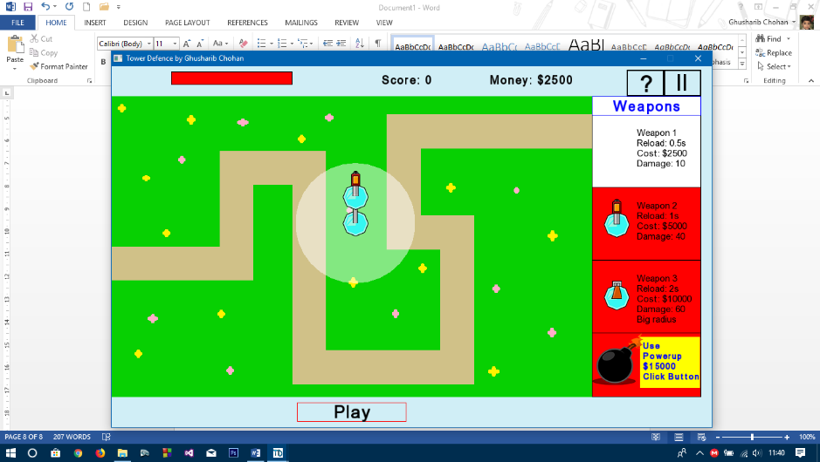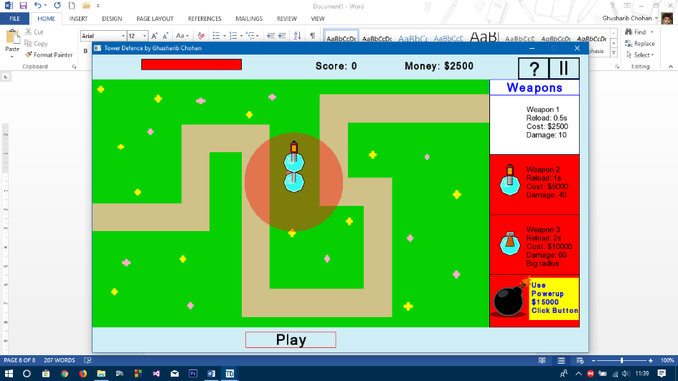

**[TEST PASSED]**

**Play Button**

Test 1) Press the “Play” Button to run the simulation

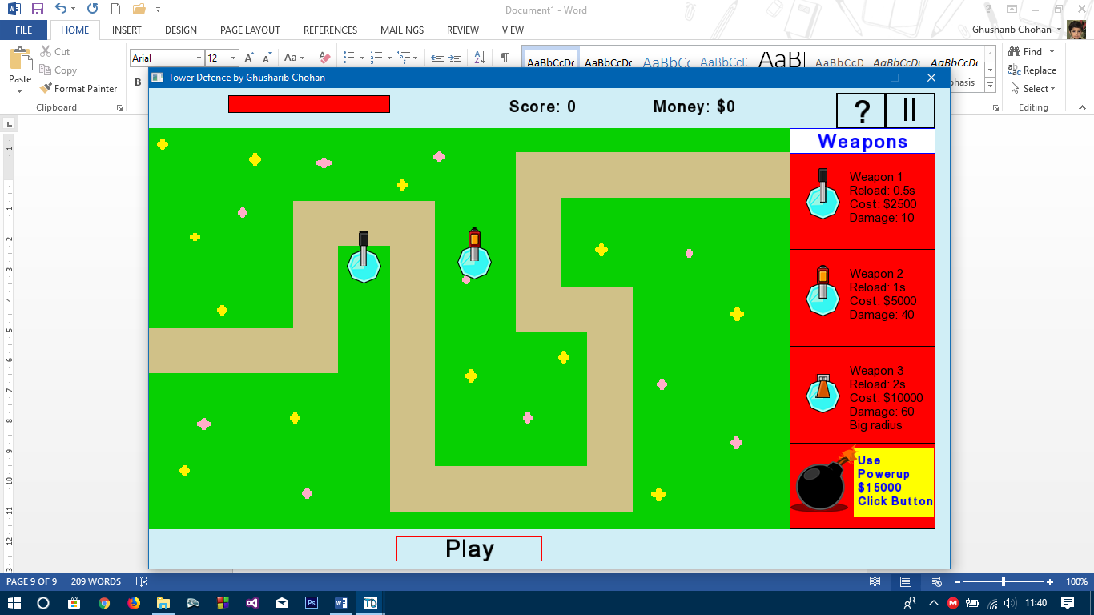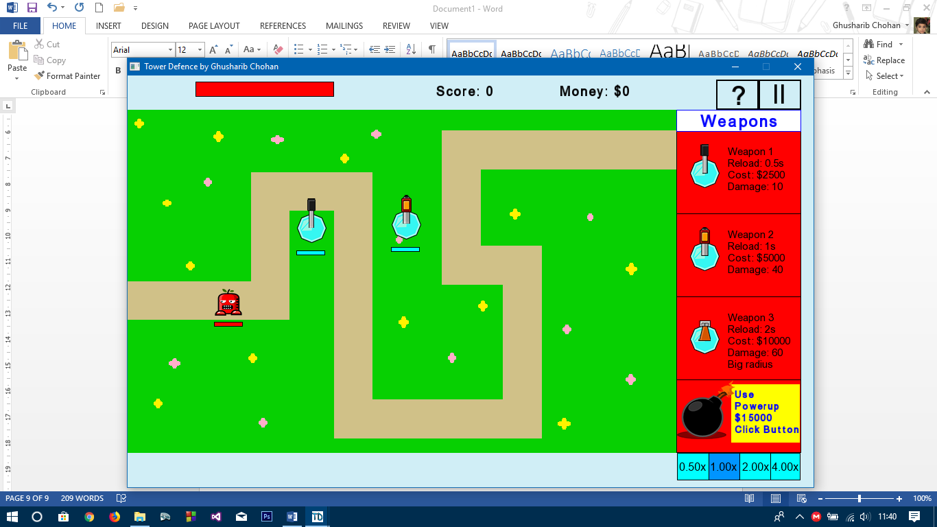

I press the Play button and the play button disappears. Enemies then are added to the map and begin to move. **[TEST PASSED]**

**Speed Buttons**

Test 1) Press the 0.5x Speed Button

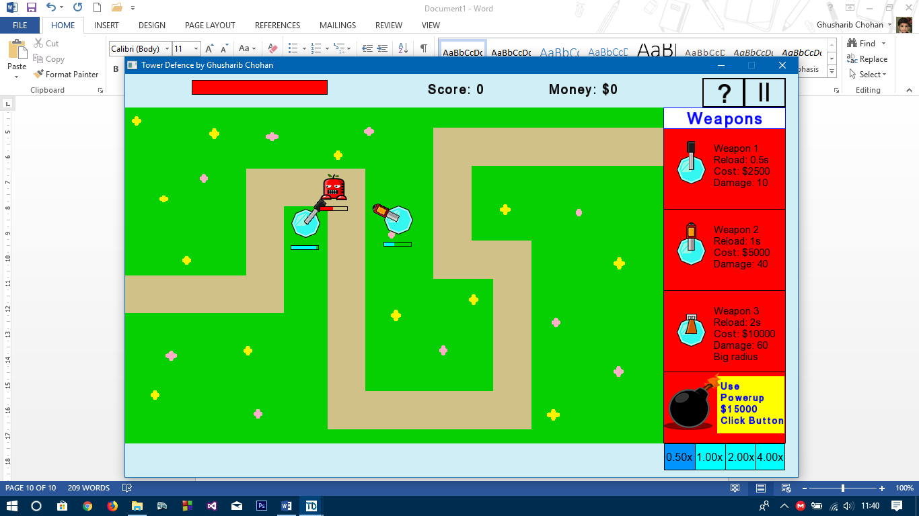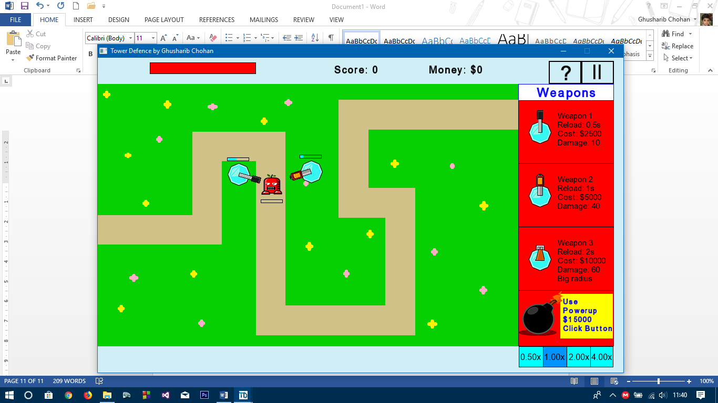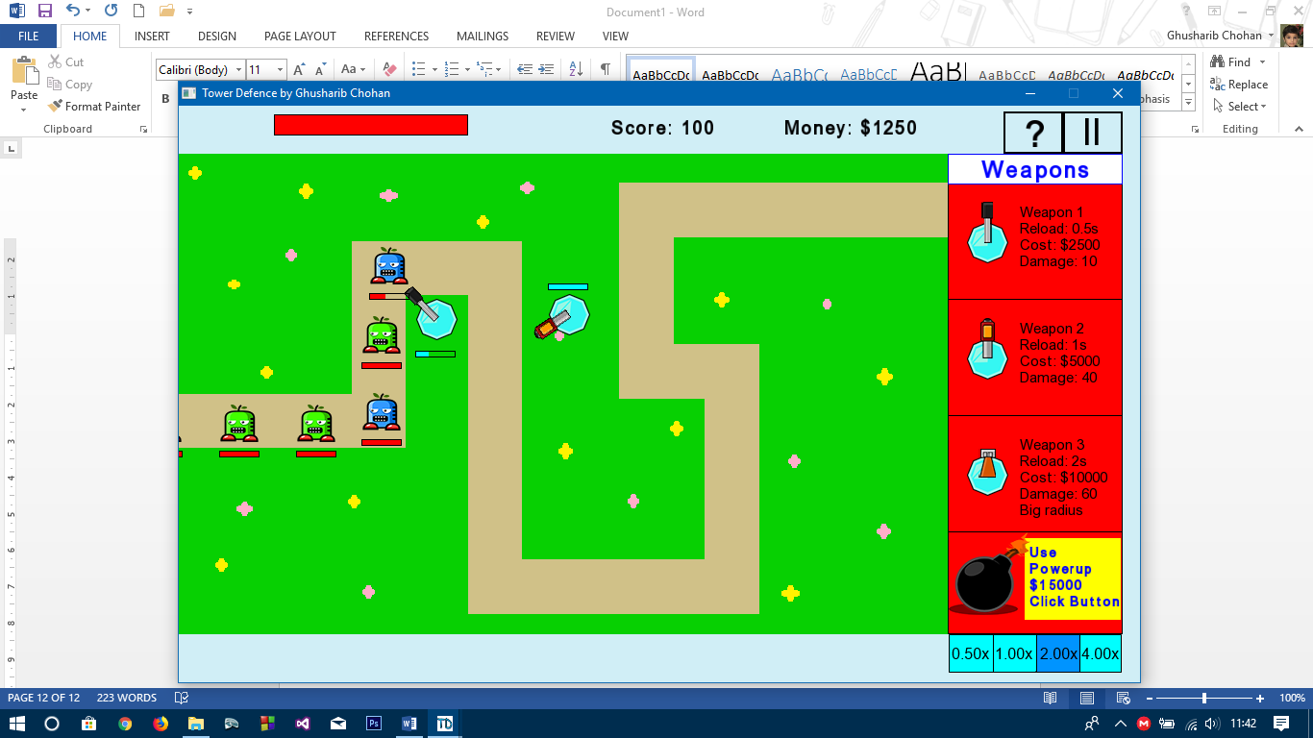

The 0.5x Speed Button is now selected and the speed of the game is slowed down

Test 2) Press the 1.0x Speed Button

The 1.0x Speed Button is now selected and the speed of the game is sped up again returning to its original

Test 3) Press the 2.0x Speed Button

The 2.0x Speed Button is now selected and the speed of the game is sped up

**[TEST PASSED]**

**I had now lost so had to restart the game**

Test 4) Press the 5.0x (This was changed to 4.0x in the actual game) Speed Button

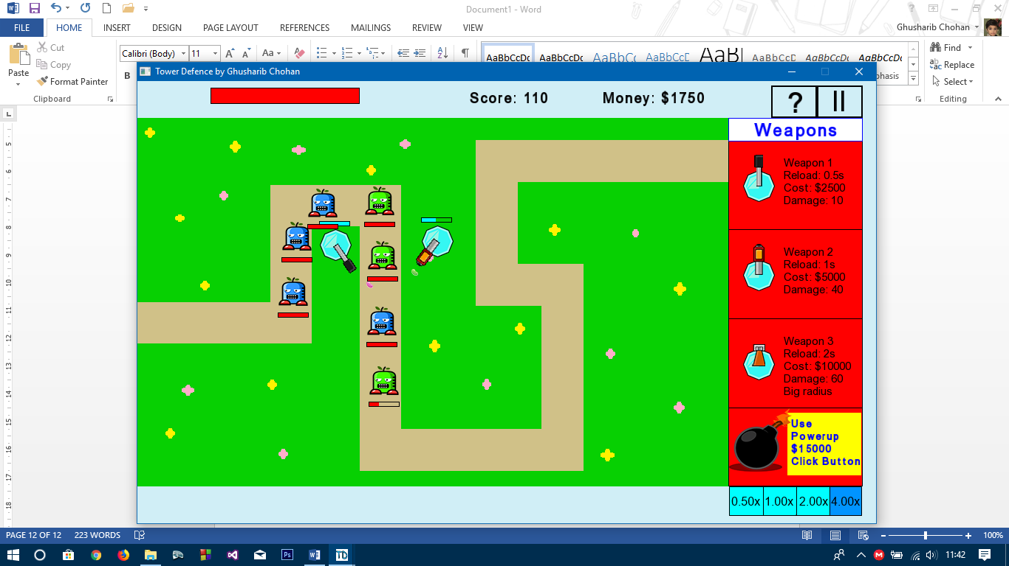

The 4.0x Speed Button is now selected and the speed of the game is sped up

All the speed options work **[TEST PASSED]**

**Health Bars**

Test 1) Have an enemy come under fire from a weapon

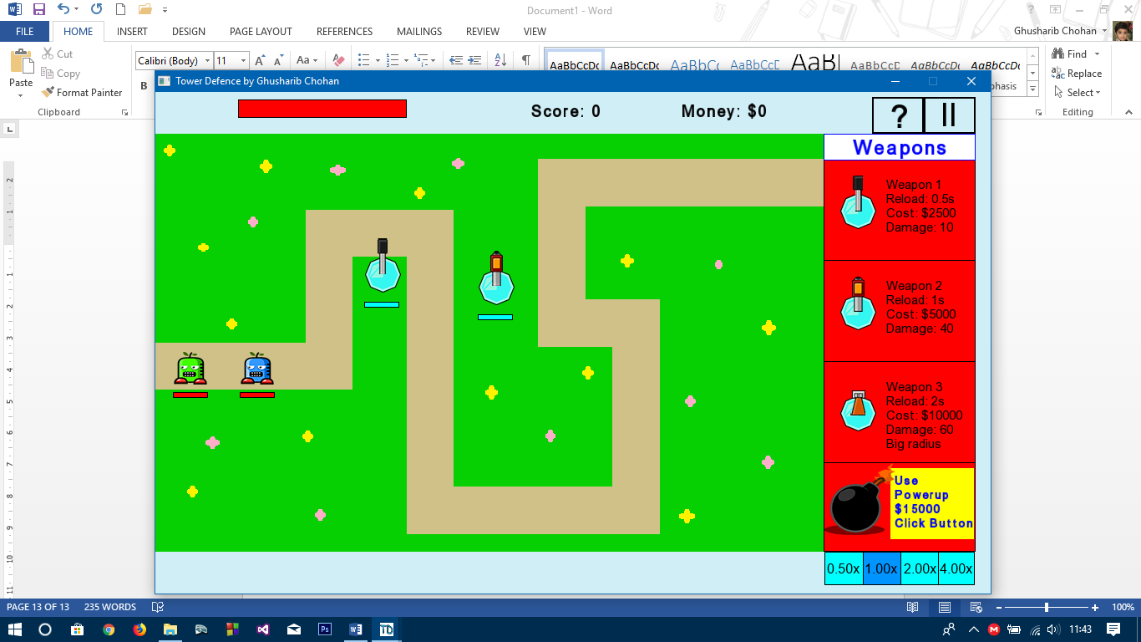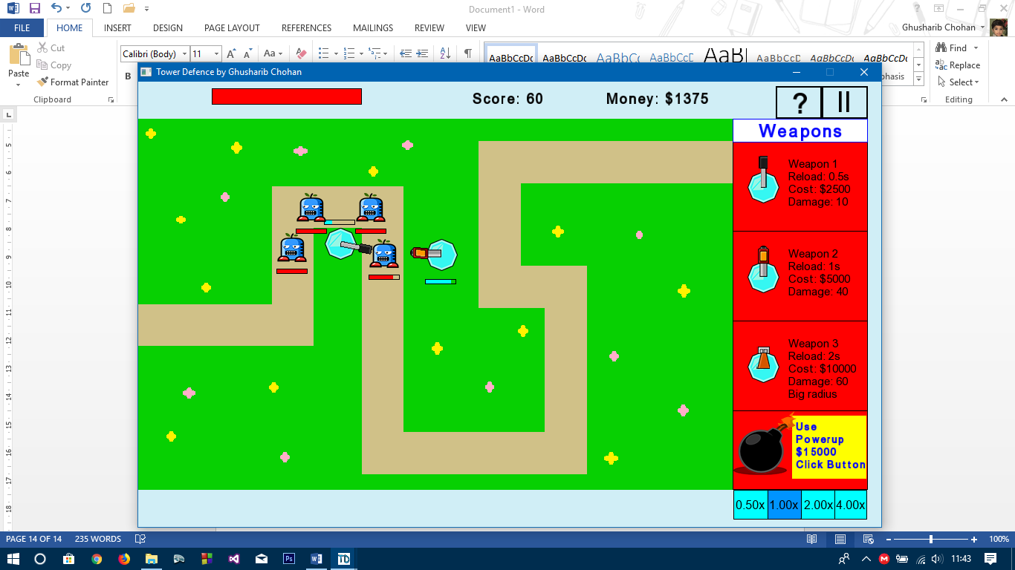

**1**

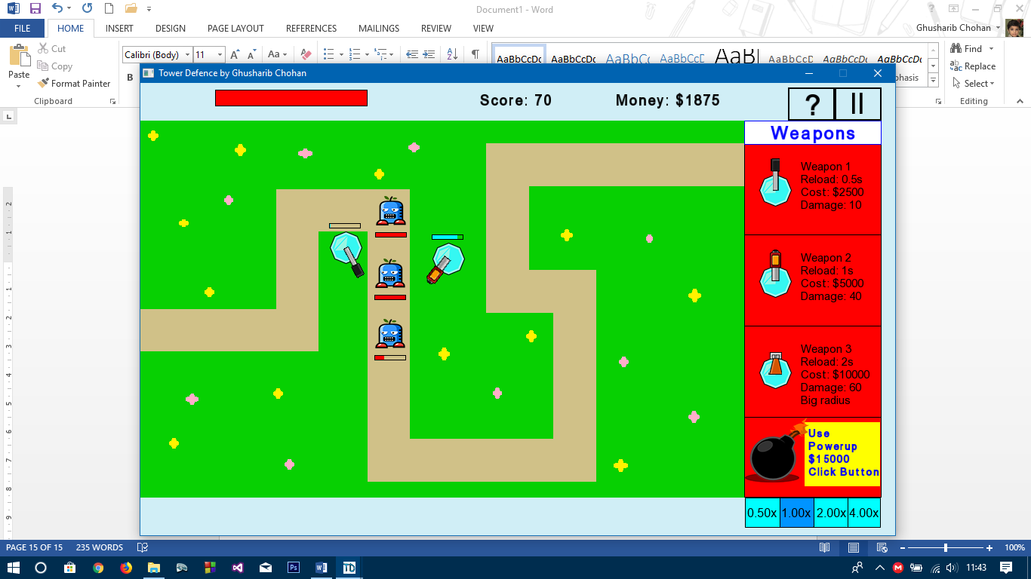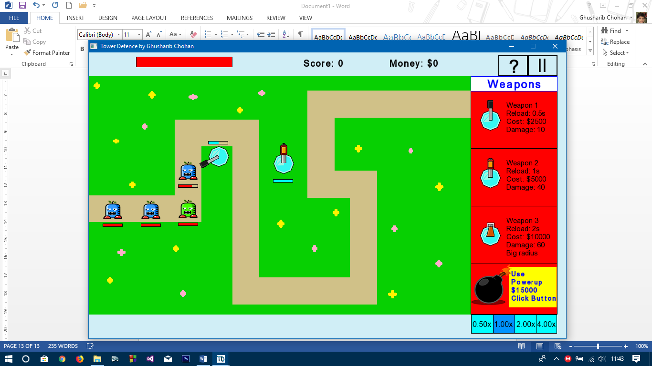

The reload bars are working as after they have fired at the enemy, they begin to reload and do not fire until they have fully reloaded

The health of the first enemy is full, but after being fired at by the weapon, it’s health goes down. This shows that the health bars are fully working

**2**

Test 2) Have Enemies reach the end of the map so that they damage the tower health, so that the towerhealth bar also decreases.

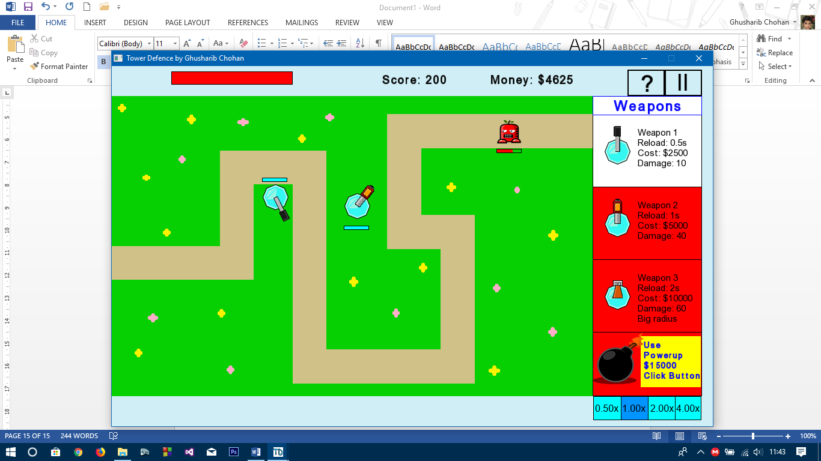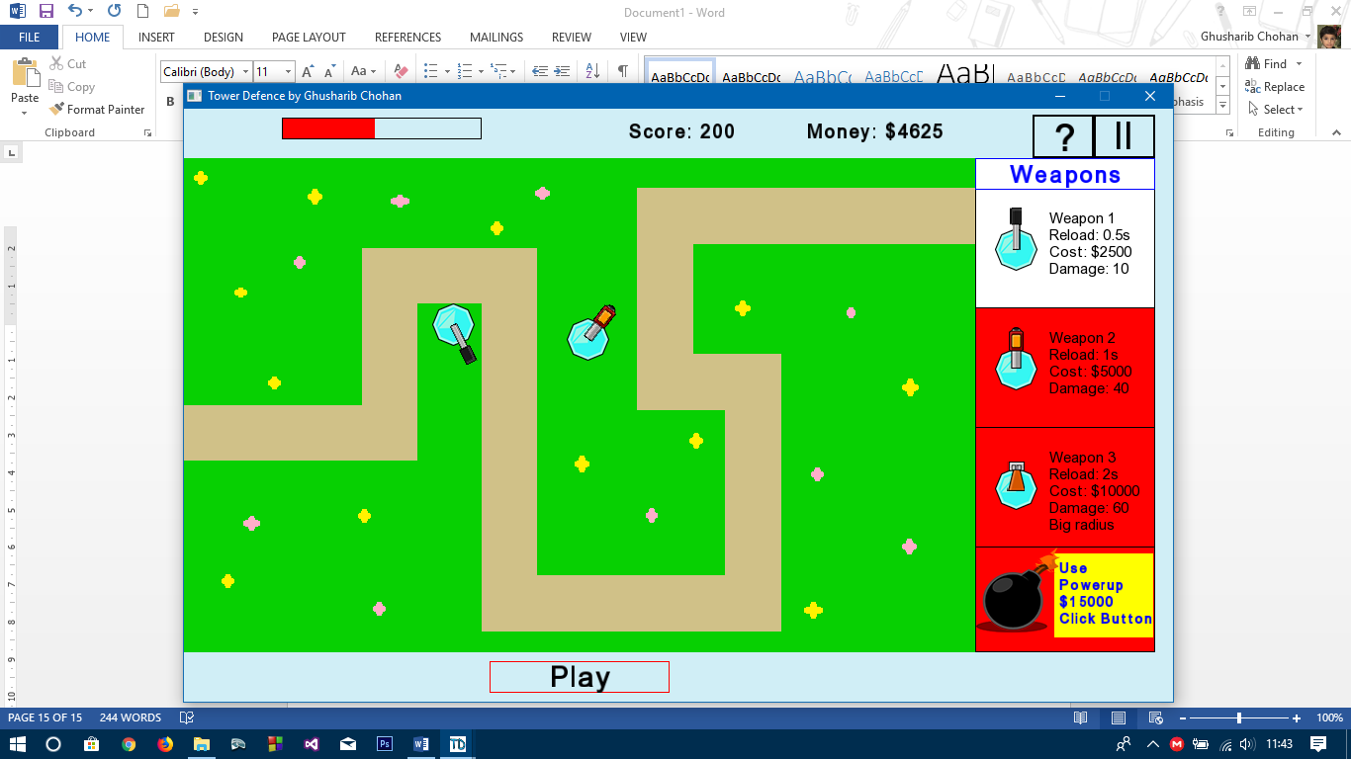

**1**

**2**

The enemy is reaching the end of the path with appoximately half of it’s health left. This means it will be able to attack the tower.

Upon reaching the end of the path, it is removed from the screen, and the tower health is decreased based on the health the enemy had upon attacking. The health abr can be seen to have decreased.

So All health bars and reload bars are working **[TEST PASSED]**

**In-Game Money System**

Test 1) Buy a weapon with enough money

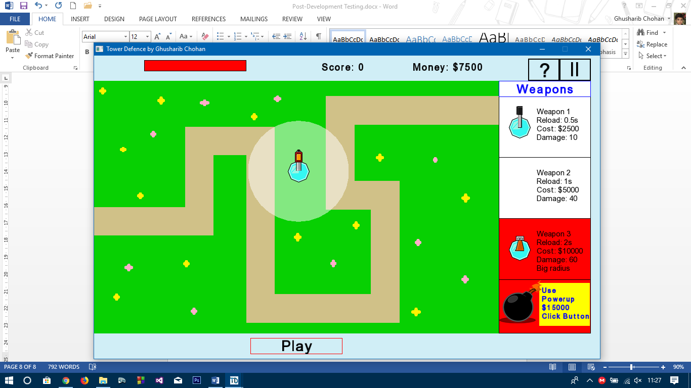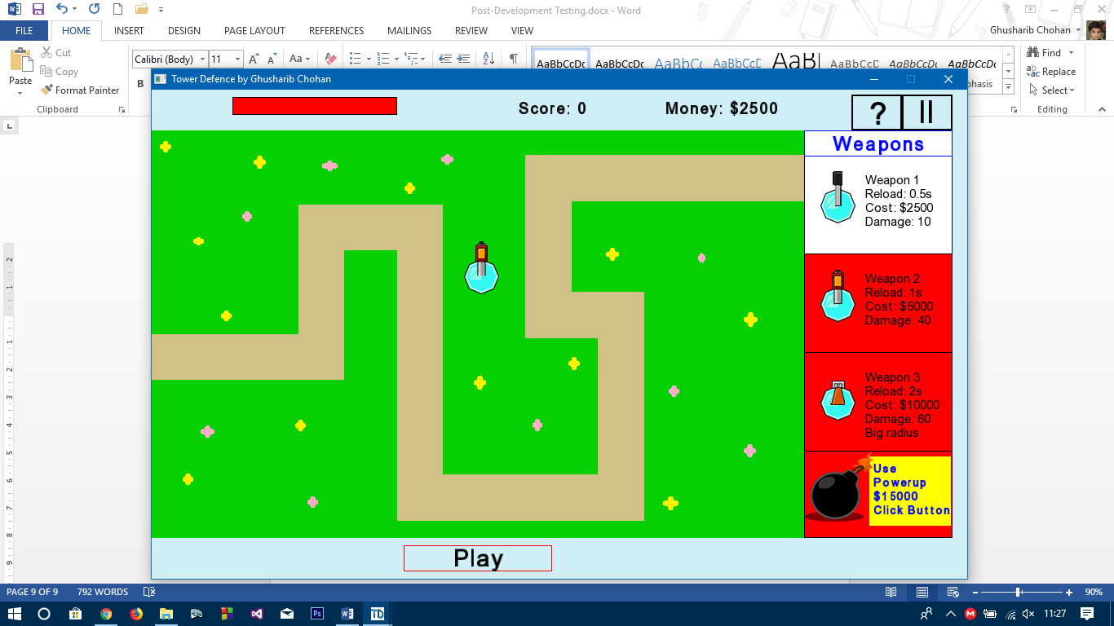

Weapon 2 is dragged onto the map when the user has enough money to buy it into a valid position (signified by the white radius)

As can be seen, the money has decreased by $5000 – the cost of the weapon – and Weapon 2’s background has turned from white to red signifying they can no longer buy a Weapon 2 (Which satisfies Test 2)

Test 3) Click and drag a weapon and sell it

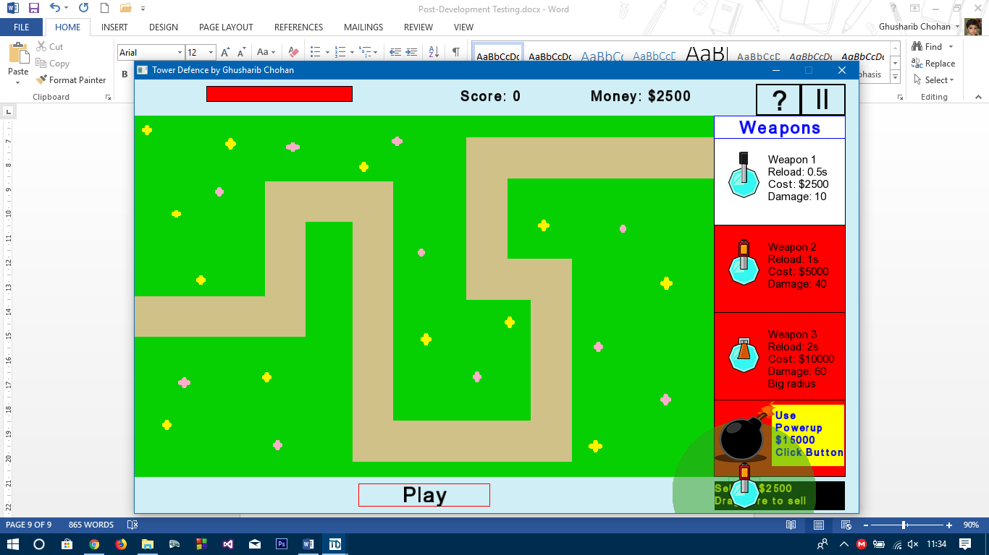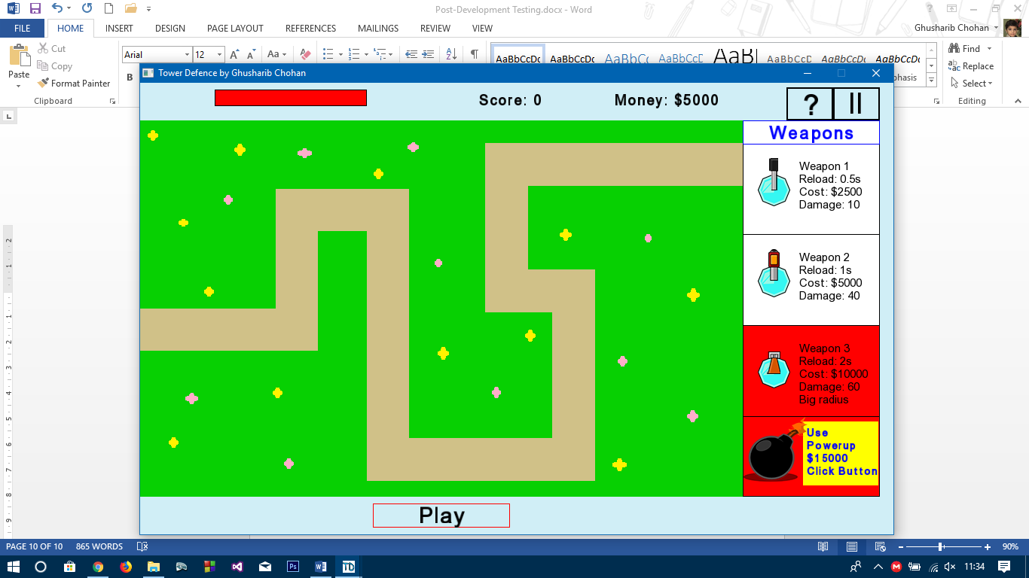

I clicked and dragged the weapon over to the black box where I can sell it. The weapon radius goes green signifying it is about to be sold if the mouse is released and says you will get $2500 back

The money then has $2500 added to it going back to $5000 showing

Test 4) During the game, an enemy should die and money should be added as a result

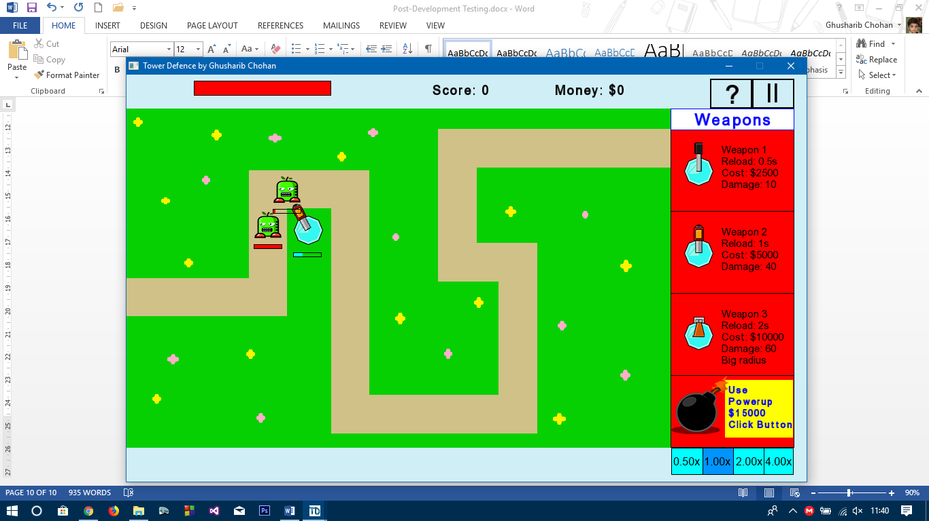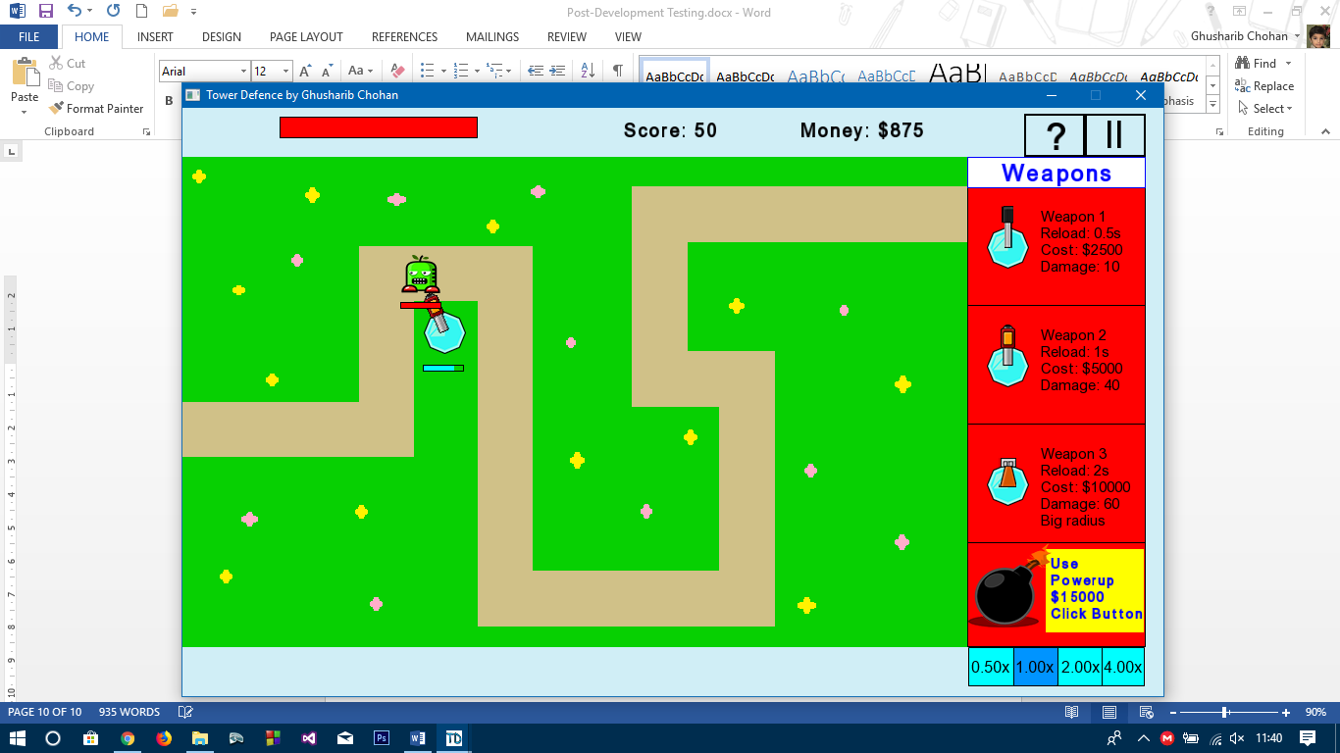

The health of the enemy being fired at is almost zero, and the money is currently $0

After the enemy dies, the user gets $875 for killing Enemy Type 2.

The money system works **[TEST PASSED]**

**Score System**

Test 1) Let an enemy die and score should increase. We can use the previous screenshot to see that it does work. The score has gone from 0 to 50.

**[TESTS PASSED]**

**Emergency Powerups**

I will combine the 4 tests for this as one as they can be tested as I play the game. The tests are as follows:

1. Use Powerup with enough money
2. Use Powerup with enough money but already used
3. Use Powerup without enough money
4. Use Powerup without enough money and already used

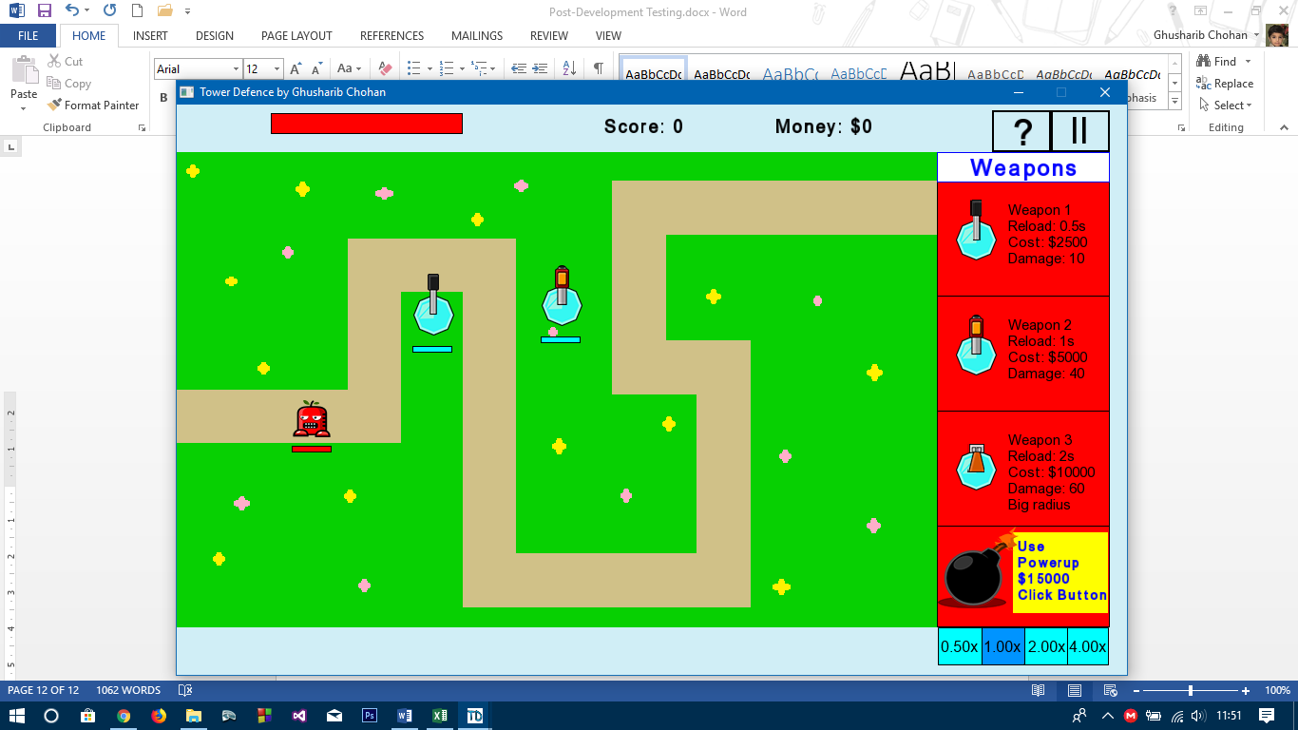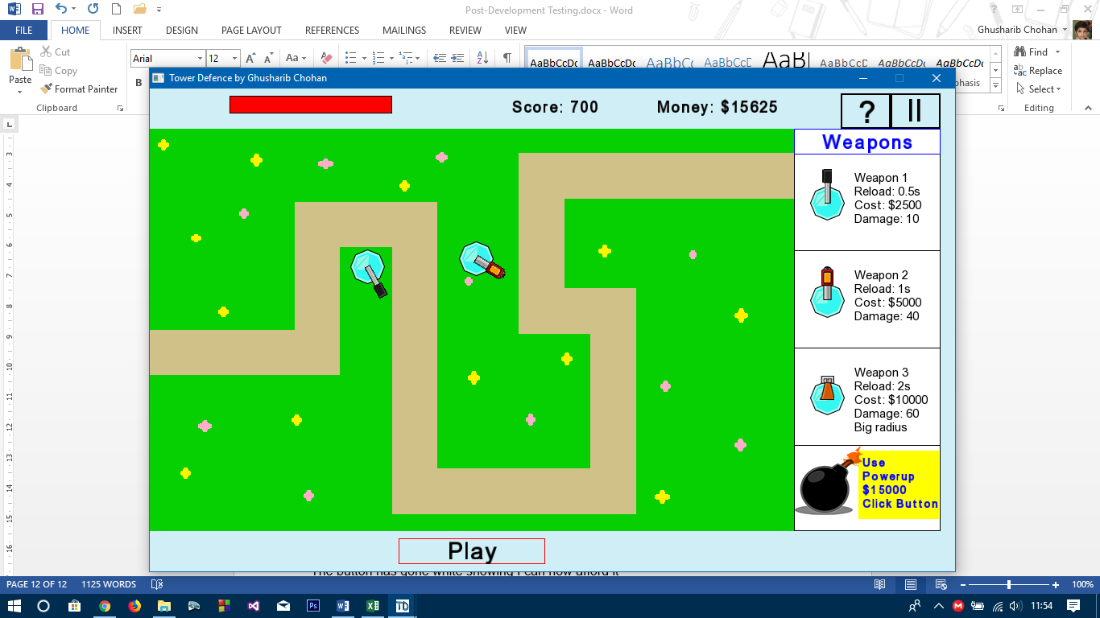

Initially, we can see that the background for the powerup is red. This, as suggested before, shows the user they cannot afford it. Attempting to use the powerup leads to no reaction as they cannot afford it and so cannot use it (note this is a button, not a click and drag)

I continue to progress through the game and it takes time before I can finally afford the powerup. This is as it should be to ensure that the user has played for a significant amount of time before being able to use the powerup.

When I can afford the powerup this happens:

The background has gone white showing I can now afford it and can use it. However, the current wave has ended so I do have to start another wave to use it – you can only use the powerup when the play button has been pressed

I then proceed to click on the Use Powerup Button and as expected, the animation begins:

There are a few things to note here for the tests.

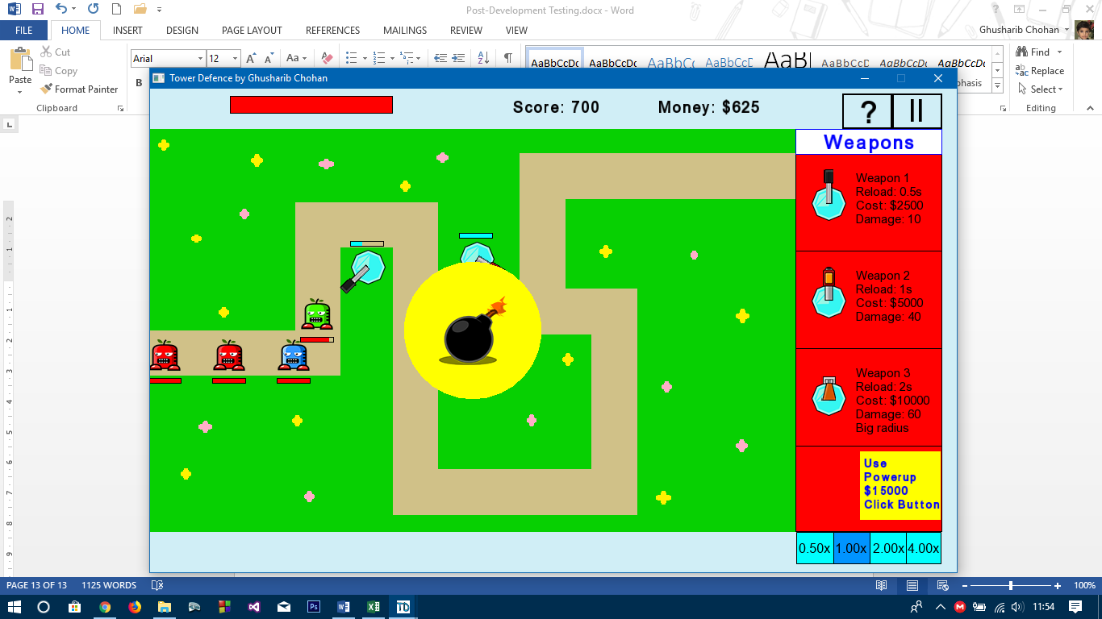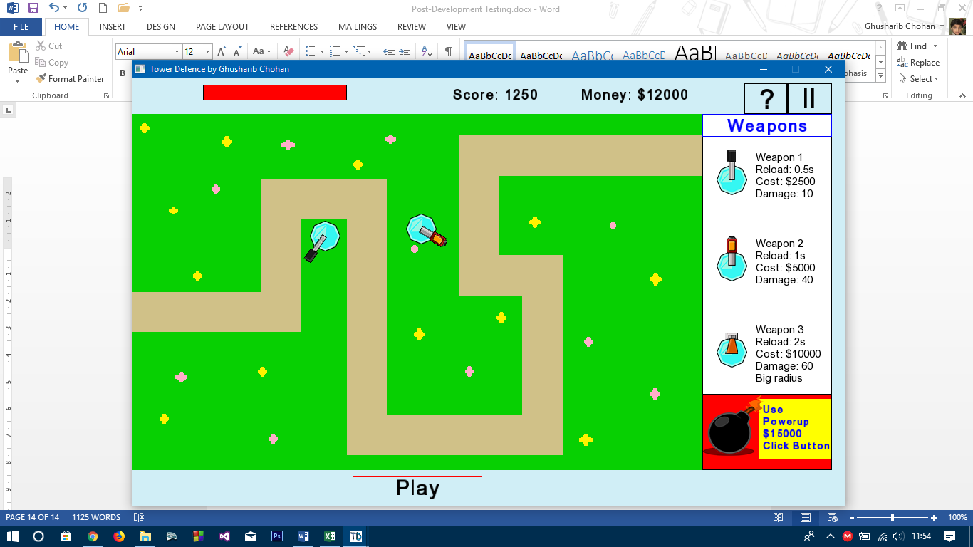

1. The money has decreased as a result of using the powerup
2. The powerup animation is running

The animation runs all the way through and then this is the result

The score and money has now been added to the user’s running totals from killing all the enemies

All the enemies from the screen have been removed and the game returns to the add weapons loop

Now that the weapon has been used, pressing on the button does nothing regardless of whether or not you can afford the powerup. We can therefore confirm that the powerup works as it should

**[TESTS PASSED]**

**High Scores**

Test 1) Lose the game

I purposely lose the game I was previously playing and this screen appears. Here I have two options – the first is the one that is being tested

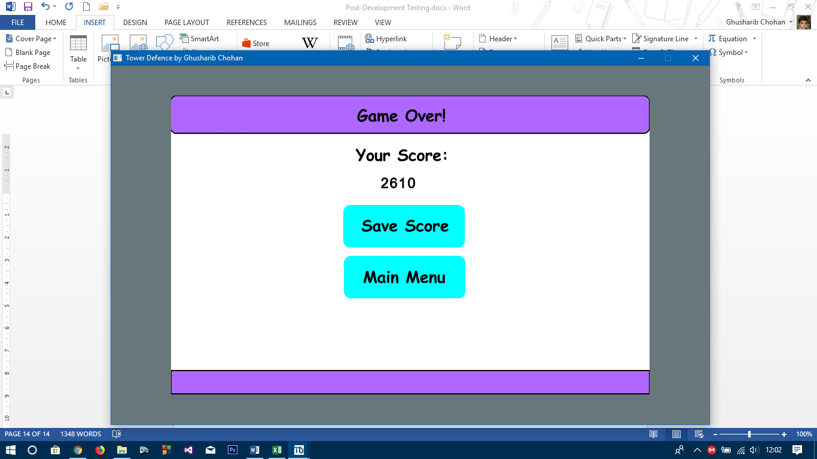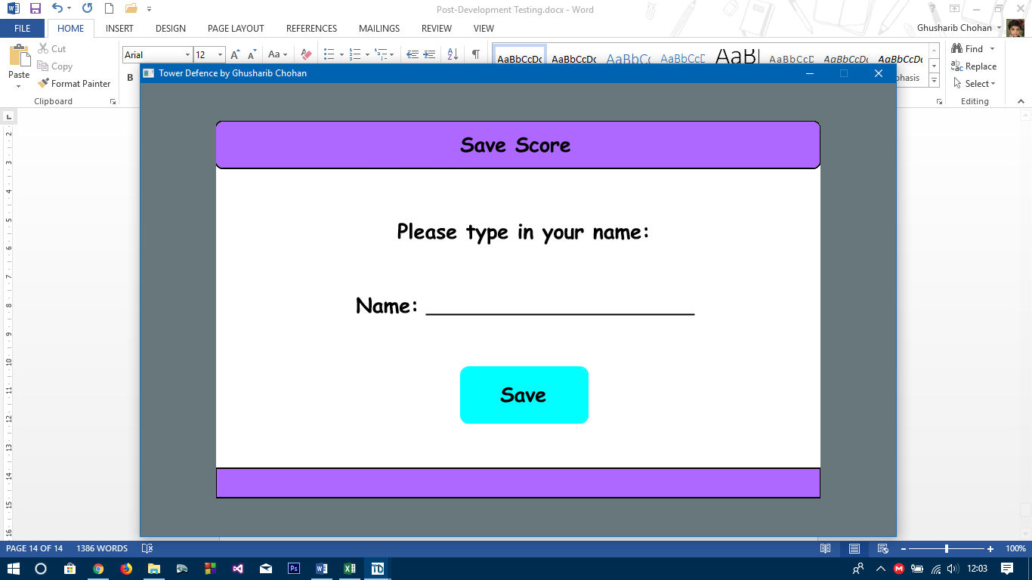

I click on the “Save Score” Button to save my score

I am greeted by a screen requesting me to input my name

I enter the name “Testing Save Score” to show where in the file the score ends up. I then click on the “Save” Button

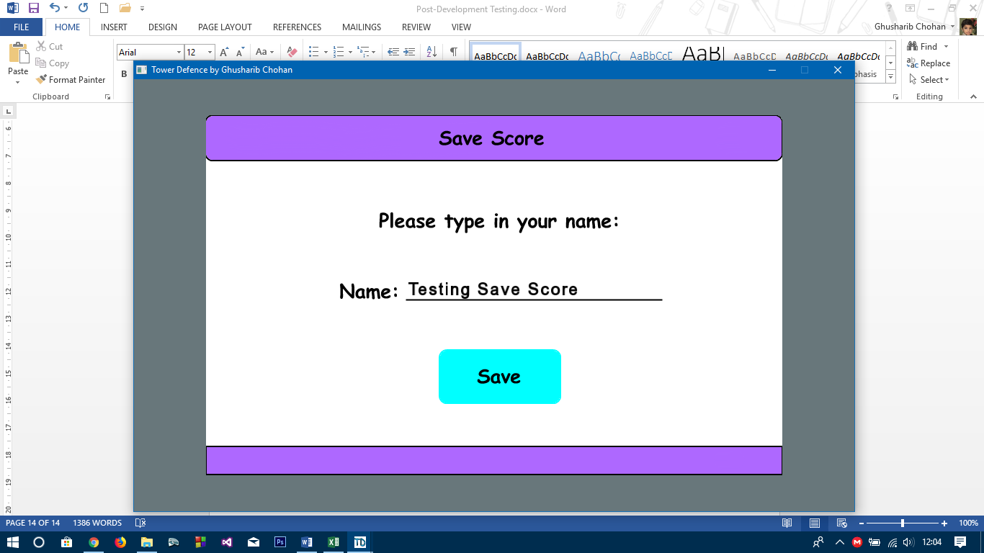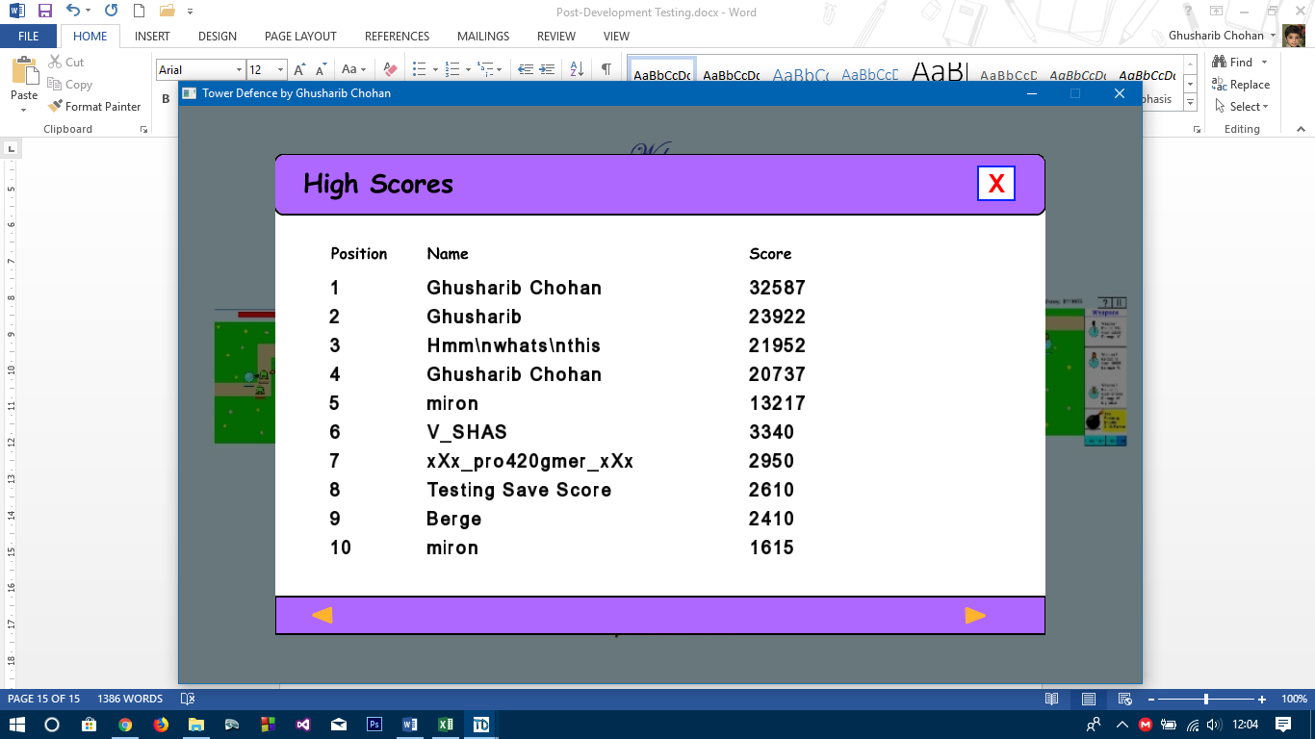

The score ends up in the correct position in the high scores table.

It should also be noted that attempting to break the file with “\n” (delimiters for when a new line occurs) has no impact on the durability of the high scores file and you are unable to add commas, as can be seen by the Name in Position 3.

The highscores option came up automatically when I lost the game as was required and therefore this works perfectly

**[TEST PASSED]**

**Random Games**

Test 1) Play the game three times and see if you get a random game each time

Below are screenshots of three games and the enemies I got in the first wave of each game:

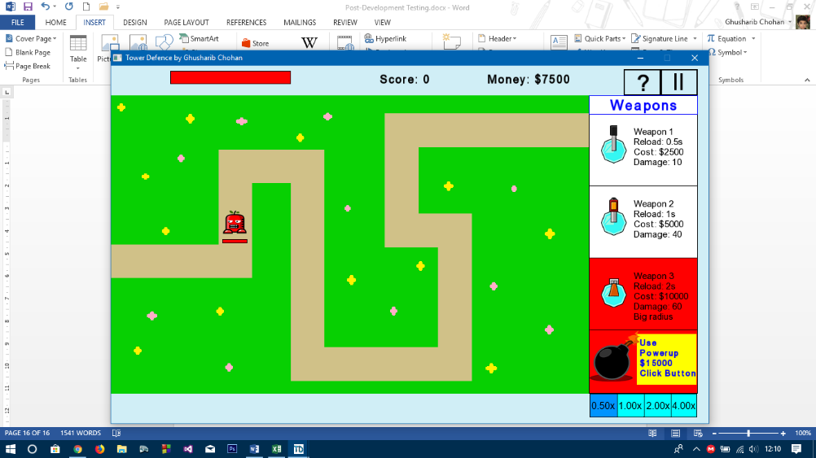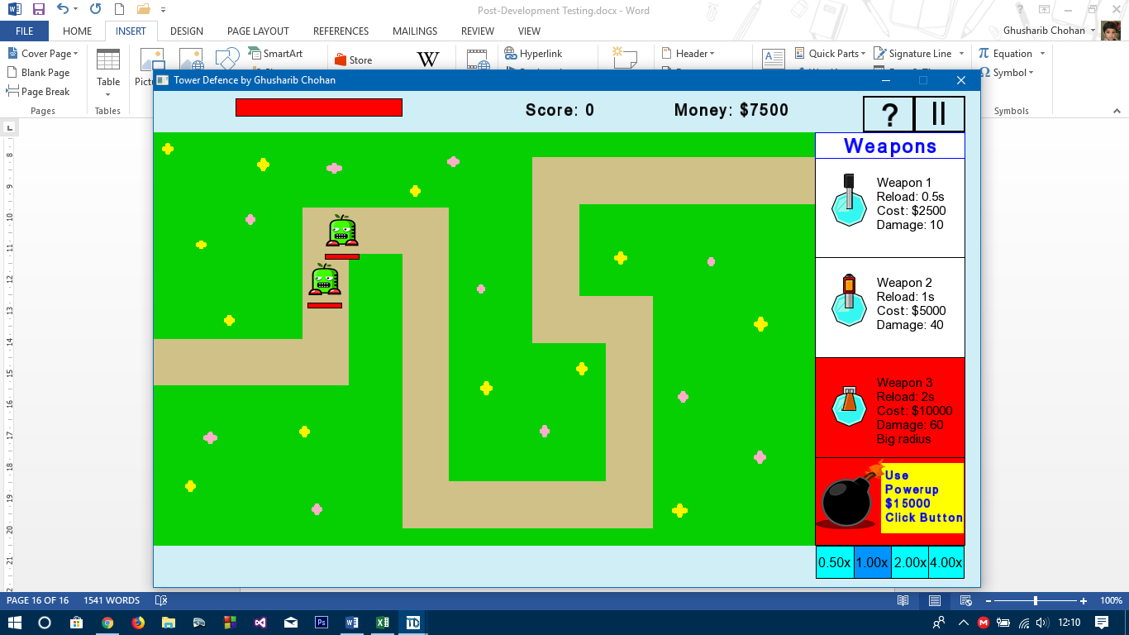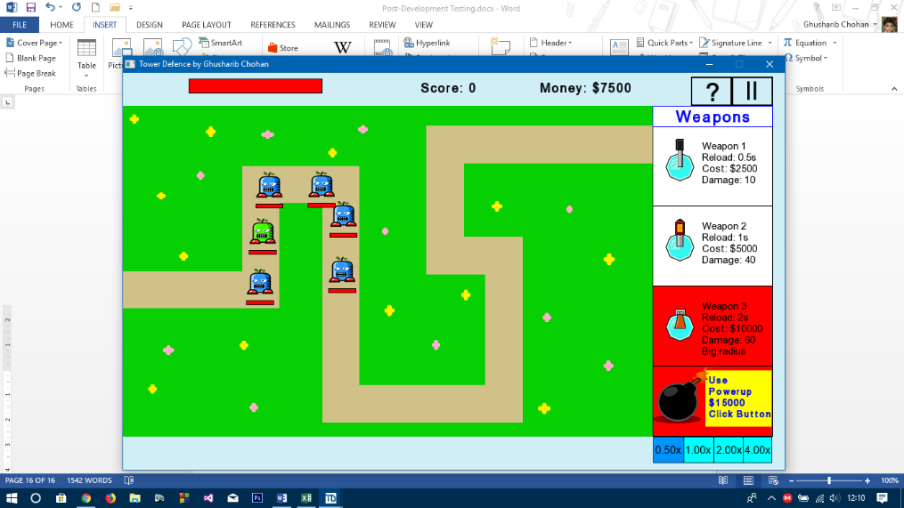

As can be seen, I get three completely different games each time.

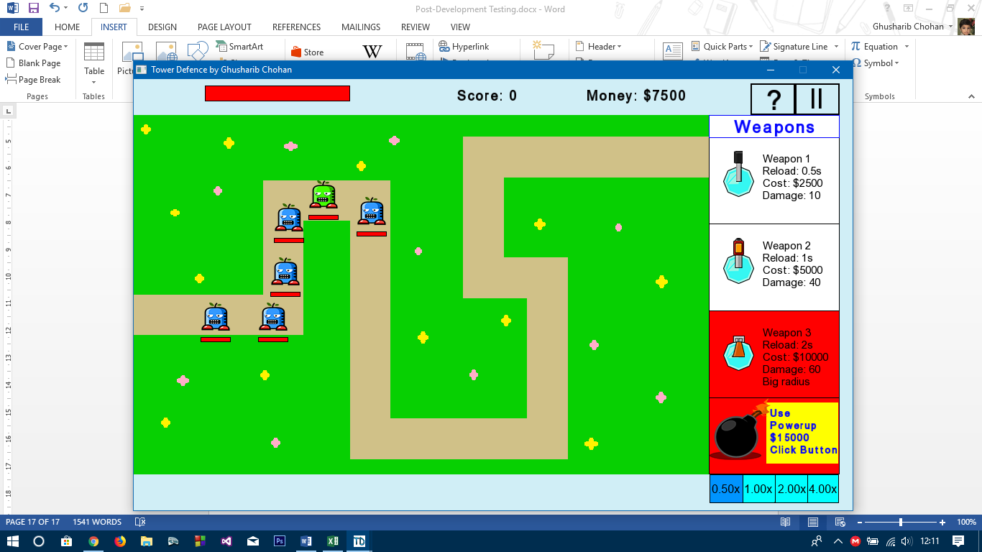On my fourth game, I got the same enemies as Game 1 but in a different order, suggesting that enemies are added truly randomly: **[TEST PASSED]**

**Game Endless Until Failure**

Test 1) Play Game 3 times

There is no way of showing that the game is endless until failure through screenshots, but each time, the game would not end until the tower health reached zero, so I can safely say the test has passed

**[TEST PASSED]**

**Information on Next Wave of Attackers**

**[TEST FAILED]\***

**\***This test failed as this was later removed in the second problem specification that was accepted by my stakeholders, after my stakeholder Nathan decided that there was no real point in having a next wave information bar as it offered nothing to the game.

**This concludes the tests that I had to carry out**

**Final Testing Grid (Overview of previous pages):**

|  |  |
| --- | --- |
| **Test Item** | **Passed/Not Passed** |
| Click on Help Button (See Help Button Testing Section Below) | **Passed** |
| Click on High Scores Button | **Passed** |
| Click on New Game | **Passed** |
| Click on a weapon of choice and drag it to a valid part of the screen (i.e. to the game grid) with enough money | **Passed** |
| Click on a weapon of choice and drag it to a valid part of the screen (i.e. to the game grid) without enough money | **Passed** |
| Click on a weapon of choice and drag it to an invalid part of the screen (i.e. just outside of the game grid) | **Passed** |
| Click on a weapon of choice and drag it on top of a previous weapon | **Passed** |
| Press the "Play" button to run the simulation | **Passed** |
| Press the 0.5x speed button | **Passed** |
| Press the 1.0x speed button | **Passed** |
| Press the 1.0x speed button | **Passed** |
| Press the 2.0x speed button | **Passed** |
| Press the 1.0x speed button | **Passed** |
| Press the 4.0x speed button | **Passed** |
| During the gameplay, one of the enemies should come under fire by a weapon | **Passed** |
| During the gameplay, some enemies should reach the tower and attack the tower | **Passed** |
| Buy a weapon (using click and drag feature) with enough money | **Passed** |
| Buy a weapon (using click and drag feature) without enough money | **Passed** |
| Click on a weapon already placed in the game and click on "Sell Weapon" | **Passed** |
| During the gameplay, one of the enemies should die | **Passed** |
| During the gameplay, one of the enemies should die | **Passed** |
| During the gameplay, buy a powerup from the weapons menu using the click and drag feature (with enough money and not bought before) | **Passed** |
| During the gameplay, buy a powerup from the weapons menu using the click and drag feature (with enough money but bought before) | **Passed** |
| During the gameplay, buy a powerup from the weapons menu using the click and drag feature (without enough money and not bought before) | **Passed** |
| During the gameplay, buy a powerup from the weapons menu using the click and drag feature (without enough money and bought before) | **Passed** |
| High Scores | **Passed** |
| Endless Game | **Passed** |
| Random Game | **Passed** |
| Click on Help Button | **Passed** |
| Click on close button on help screen | **Passed** |
| Information On Next Enemies | **Failed** |

**User Feedback**

I decided to create a Google Forms form for the user’s to fill out for the purposes of the final testing. For this, I emailed all of them a copy of the game and the link to the form. The copy was sent in a .msi format so that it could be directly installed onto the target computer with limited input.

The individual feedback forms can be found as part of Appendix E.

The questions asked were as follows:

1. **What is your full name?** – I required this so that I could ask them follow up questions if need be and so needed to know which of my stakeholders was giving the responses
2. **Out of 10, what would you rate the game?** A rating out of 10 is quantifiable and allows me to easily work out whether or not the user enjoyed the game. This was therefore the easiest and best way of understanding whether or not the user enjoyed the game.
3. **What is the reason for your above rating?** Once I have a rating, I would like to know why they think this is x out of 10. This is because this will allow me to understand the strengths of my game as well as any weaknesses very quickly.
4. **Did you notice any bugs?** If I later on make any updates to the game, I will need to remove bugs that they may have noticed. These bugs are not always noticed by me, the developer, as I am not playing the game the same way my users are and therefore, it is important for me to ask this question.
5. **How long did you spend playing the game?** This is another quantifiable question allowing me to further understand how much they enjoyed the game. I previously stated that I expect users to play the game for 30 minutes for my game to be considered successful so this will be key to my understanding.
6. **Accepting the problem specification.** This has checkboxes for the entire problem specification. Users can tick off all the boxes they feel have been successfully achieved. This will help me see whether or not the users feel as though the things they requested in the game have been met or not.
7. **Are there any additions you would like to make to the game?** Once again, if I were to update the game at a later stage, I would like any suggestions to be taken into consideration, and my users are the best people to ask.
8. **Any final comments?** This is for their own general use and is not a requirement to be filled out.

**Summary of Responses**

As stated before **Appendix E** contains all the individual responses.

Below is a summary of the responses and what I get out of them:

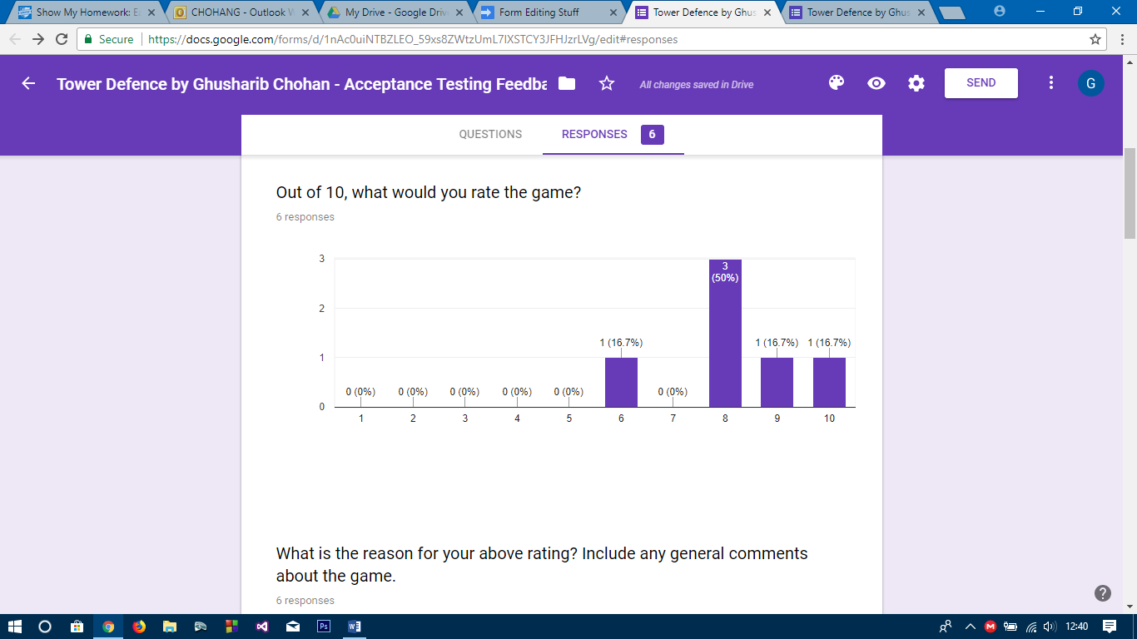

My modal rating for the game was 8/10 with 50% of my stakeholders giving it 8 out of 10. There were some unusually high and unusually low ratings as well including a 10/10. This meant I had an **average rating of 8.2/10** which can be considered to be a very good rating by which I am pleased.

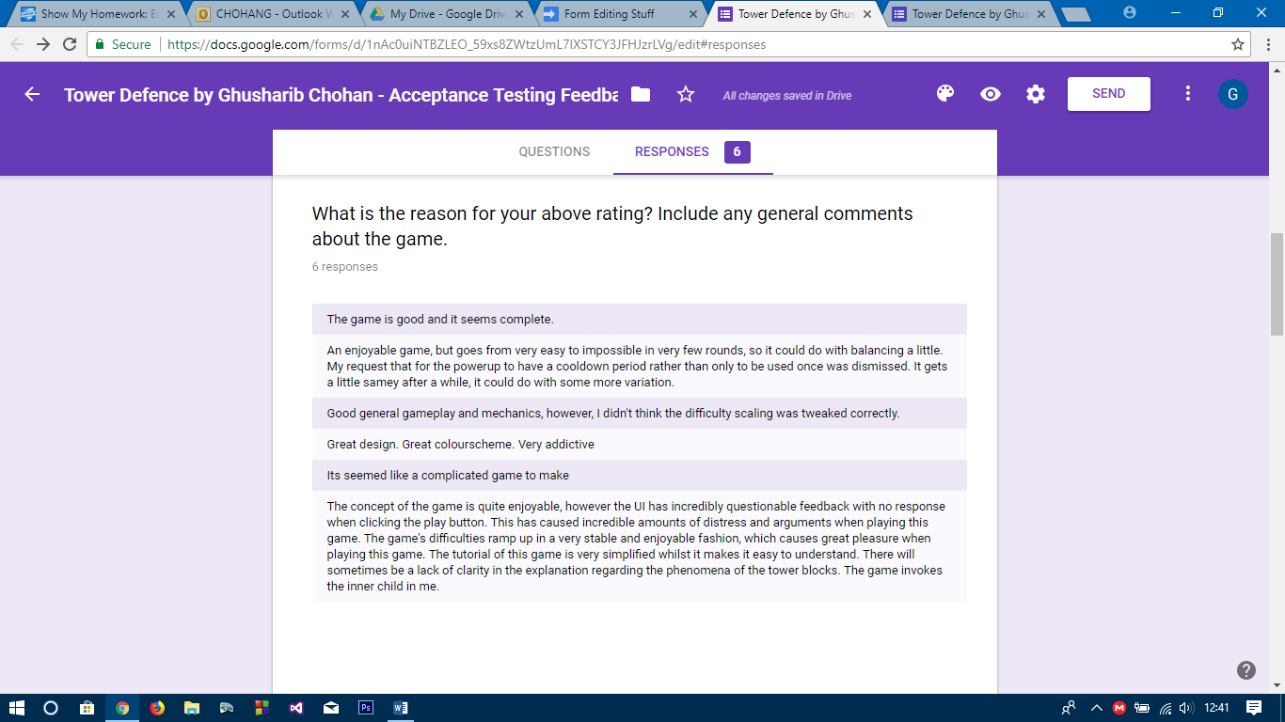

In terms of reasons for these ratings, everyone seemed to enjoy the game (with one even suggesting it brought out their inner child). However, some did suggest that the balancing of the game was not quite there as per their requests (despite the improvement of Weapon 3 back in Iteration 6 of the devlopment) and that there were a few issues with the User Interface. However, these seemed to be specific to one user only and there was no general consensus on what was good and bad. Everyone had different opinions on the strengths and weaknesses of the game.

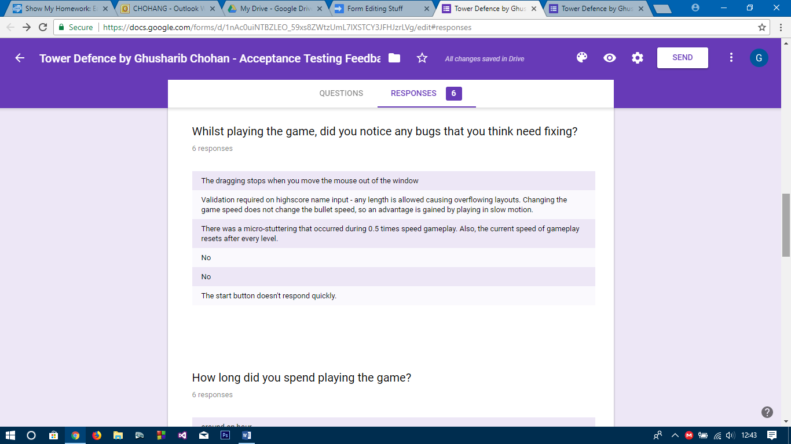

One noted that dragging stopped when the mouse moved out of the window. However, this was not a bug, but rather a feature of the game. If the mouse exits the game screen, the weapon is in an invalid place and therefore cannot be placed outside of the screen. This means that the game is working as it should and so this is not a “bug” that needs consideration.

Another suggested overflow in the highscore name input. This was a valid bug which will be fixed in future versions of the game. However, micro-stuttering was only pointed out by one user and it may be down to the computer they were running the game on. The same can be said about the start button.

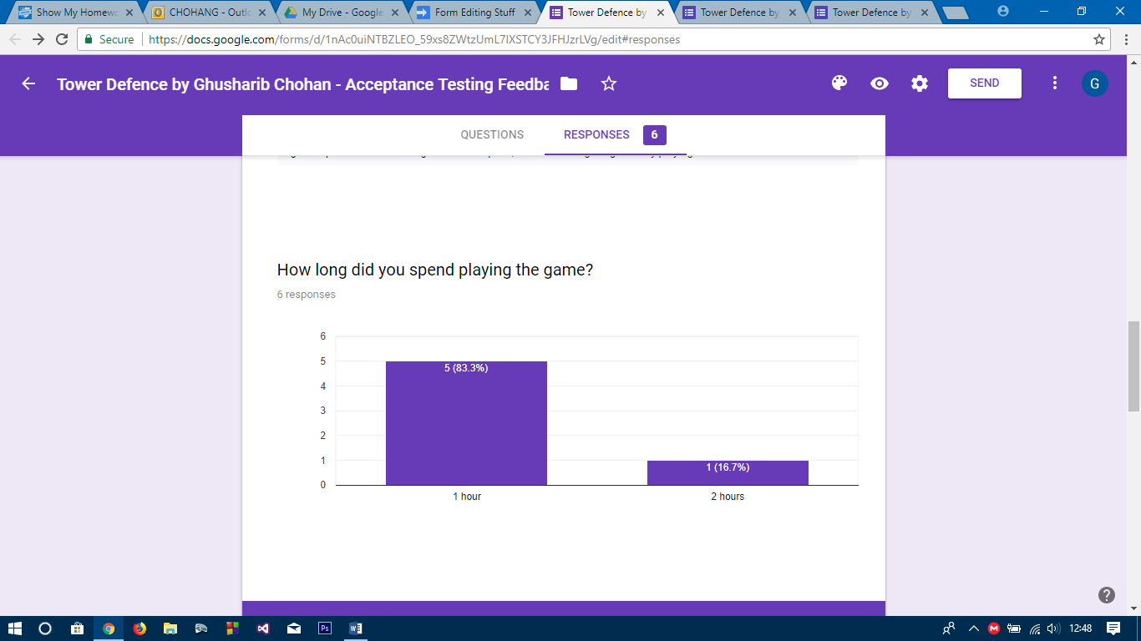

All of my users played for longer than I expected them to. 5 out of 6 (83.3%) played for one hour and the other user ended up playing for two hours! This was very unexpected and pleasing and shows that my stakeholders were not only satisfied with the game, but also very addicted to it!

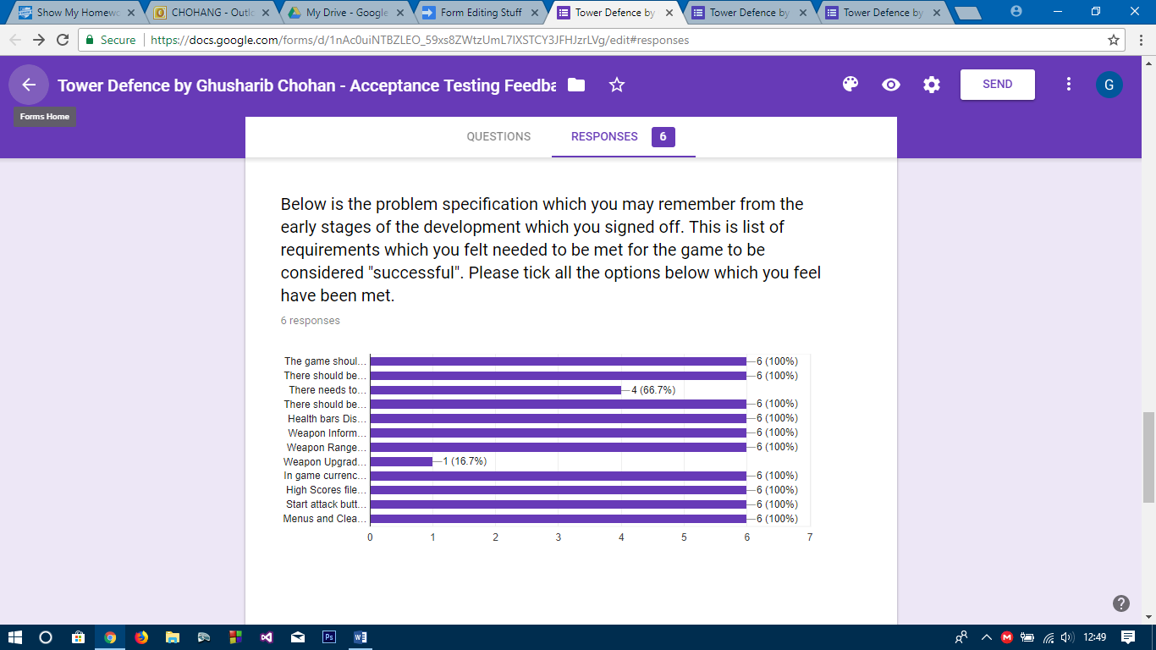

Most of the problem specification appears to have been achieved. However, 2 out of 6 of my stakeholders felt that the game was not balanced and most of my stakeholders did not feel as though weapon upgrades were a thing in my game. I agree with this as I forgot to add upgradability, but this was partly because upgradability was something I felt would ruin the balance of the game even further, and therefore is not a feature that I will be willing to add to the game soon. Upon asking for further feedback, many of my users agreed that weapon upgradability was not a feature they felt was required very urgently. This concludes the main parts of the survey.

I have now received user feedback and carried out all the testing parts as were set out in the design stage.